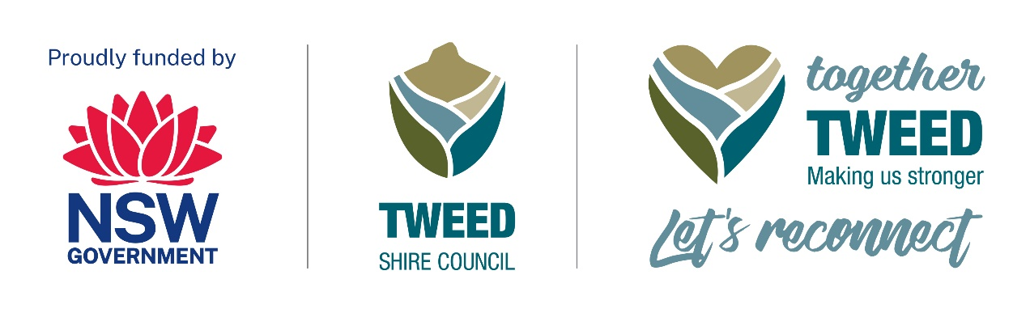Resilient Uki
The Uki Stomp

Event accessibility
The following accessible features will be available at The Uki Festival:
- One accessible toilet
- Designated drop-off zones by the entry of the festival on Kyogle Road
- Designated accessible parking
- ‘Chill Out’ and quiet spaces
- Designated accessible seating near the main stage
- Marshalls to assist
- Assistance animals welcome
Accessible/wheelchair access is indicated on The Uki Stomp event map with clearly marked green pathways. The map is available as a PDF file and can be viewed on Tweed Shire Council’s ‘Together Tweed: Let’s Reconnect’ webpage under the ‘Event accessiblity’ heading using this link: Together Tweed: Let’s Reconnect | Tweed Shire Council (nsw.gov.au)

Access services
A chill out space (i.e., break out space) is available in Uki Hall for attendees that need a quieter space away from the live music and crowds.
There is one accessible toilet located in the permanent public toilet block behind Uki Hall.
Dedicated accessible parking will be located by the entry to the event along Kyogle Road, in front of the Old Buttery Precinct.
Designated accessible seating undercover marquees is provided close to the stage for accessible access and viewing.

Getting here
The Uki Stomp is located at the Uki Village Green and the Buttery Grounds at 1462 and 1454 Kyogle Road in Uki, NSW. Designated drop-off points are located at the entry to the festival on Kyogle Road in front of the Old Buttery Precinct. Designated accessible parking can be accessed on Kyogle Road in front of the Old Buttery Precinct. Volunteers will be available to assist with drop-off and parking.
There is no public transport, but vehicles, private or professional can park by the entry to the event for as long as they require.

Mobility
There is pathway access to most places in the festival. Designated accessible toilets are located close to the permanent Uki Public Toilets, about 15 metres from the entry of the festival on Kyogle Road, and can be accessed via the pathway between the Uki Village Green on the right and Uki Hall on the left.
The main stage and the designated shaded accessible seating area is accessible via Norco Street, off Kyogle Road and towards Milsoms Lane and the Artisan Market Stalls. Resilience Row can be accessed from Kyogle Road, along the right side of the Old Buttery Precinct.
Food trucks will be located along the front and rear of the Old Buttery Precinct. Marshalls will be available to assist with any questions or mobility needs.
The Uki Stomp Site Map is available on Tweed Shire Council’s ‘Together Tweed: Let’s Reconnect’ webpage under the ‘Event accessiblity’ heading. To access the Site Map as a PDF file please use this link: Together Tweed: Let’s Reconnect | Tweed Shire Council (nsw.gov.au)

Accessible seating
Designated shaded accessible seating is available to the right-hand side of the main stage. It can be accessed by entering the festival from Kyogle Road and travelling down Norco Street heading towards Milsoms Lane and the Artisan Market Stalls.

Access enquiries
For access enquiries, please contact Nick Hanlon via Phone 0477 827 940, or Email rainbowregiongigs@gmail.com

Together Tweed: Lets Reconnect program
Please use this link to Tweed Shire Council’s webpage for information about other events - Together Tweed: Let’s Reconnect | Tweed Shire Council (nsw.gov.au)

