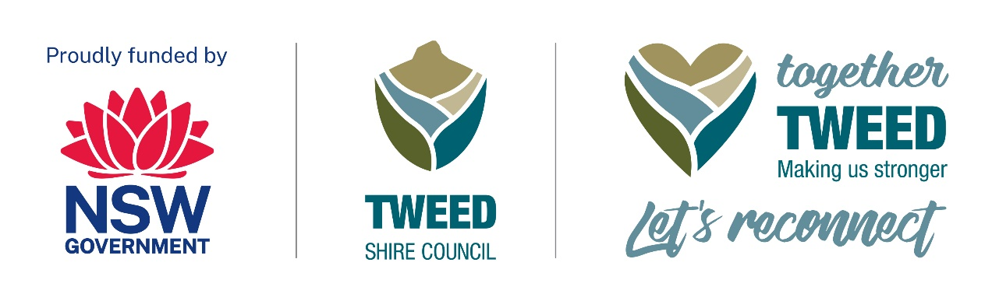Resilient Uki
The Uki Stomp

About the event
Sunday 30 July 2023. Free Entry.
The Uki Stomp is an all-day event with a local focus – celebrating the spirit of Uki village and its nearby neighbours and community resilience.
The day will begin with a Welcome to Country, followed by a Smoking Ceremony with Jarmbi and music and dance from The Kids Caring for Country Dancers.
The entertainment includes Poets Out Loud, roots music maestro Bill Jacobi, The Voice finalist and rising star, Emmagen Raine, and the retro country-swing of Way Out West featuring Warren Earl, Diego Zaragoza, Rod Coe, Matt Lydon, Pete Wilkins and Sam Sanders.
The Bianchetti Bush Dance, led by the students of Uki Primary School, will feature the best bush band in the country, The Bale ‘Em Up Bush Band, followed by the street-jazz sounds of the Whopping Big Band.
Our MCs will interview locals and performers throughout the day, who can then spin their favourite record with the Stereogram DJ on The Vault Stage.
The Uki Stomp event accessibility details are available as a word document on Tweed Shire Council’s ‘Together Tweed: Let’s Reconnect’ webpage under the ‘Event accessiblity’ heading (please access using the following link): Together Tweed: Let’s Reconnect | Tweed Shire Council (nsw.gov.au)

Event location
The Uki Village Green and Buttery Grounds at 1462 and 1454 Kyogle Road in Uki, NSW from 10am to 6pm on Sunday 30 July 2023. Free Entry.
The Uki Stomp Site Map is available on Tweed Shire Council’s ‘Together Tweed: Let’s Reconnect’ webpage under the ‘Event accessiblity’ heading. To access the Site Map as a PDF file please use this link: Together Tweed: Let’s Reconnect | Tweed Shire Council (nsw.gov.au)

Event contact details
For enquiries, please contact Nick Hanlon via phone: 0477 827 940 or email: Rainbowregiongigs@gmail.com

Event schedule
10am: Indigenous section of the event on the village green
11am: Music and MCs begin on the main stage
12pm: Bar opens
5.30pm: Last act finishes, and bar closes
An event program will be available with further schedule details.

Together Tweed: Lets Reconnect program
Please use this link to Tweed Shire Council’s webpage for information about other events - Together Tweed: Let’s Reconnect | Tweed Shire Council (nsw.gov.au)

